Throughput

🚀 What Is Throughput in Networking?
# Source: AI Source: Provided by: [Data Path: Persons Table -> ID Column: 1, Name_En Column: Motasem Essam] -> From: [ChatGPT] on [12/18/2025]
Throughput is the actual amount of data successfully transferred over a network connection in a given time. It reflects the real-world performance of a network — not just its potential.

📦 Belongs to:
# Source: AI Source: Provided by: [Data Path: Persons Table -> ID Column: 1, Name_En Column: Motasem Essam] -> From: [ChatGPT] on [12/18/2025]
✅ Network Performance Metrics
Along with Bandwidth, Latency, Jitter, and Packet Loss

🧠 Definition:
# Source: AI Source: Provided by: [Data Path: Persons Table -> ID Column: 1, Name_En Column: Motasem Essam] -> From: [ChatGPT] on [12/18/2025]
Throughput is the measured rate at which data is successfully delivered from source to destination, typically measured in bits per second (bps).
📌 Unlike bandwidth (theoretical max), throughput shows what you’re really getting.

📏 Units of Throughput
# Source: AI Source: Provided by: [Data Path: Persons Table -> ID Column: 1, Name_En Column: Motasem Essam] -> From: [ChatGPT] on [12/18/2025]
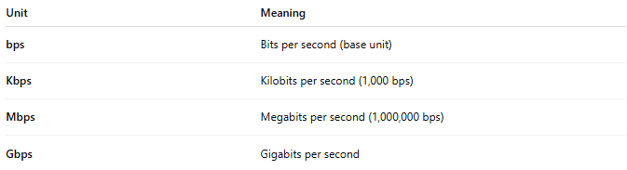
Unit | Meaning
bps | Bits per second (base unit)
Kbps | Kilobits per second (1,000 bps)
Mbps | Megabits per second (1,000,000 bps)
Gbps | Gigabits per second

🧪 Example
# Source: AI Source: Provided by: [Data Path: Persons Table -> ID Column: 1, Name_En Column: Motasem Essam] -> From: [ChatGPT] on [12/18/2025]
- You have a 100 Mbps internet plan (bandwidth)
- You download a file and get 72 Mbps download speed
→ 72 Mbps is your throughput — the actual usable rate.

📉 Factors That Affect Throughput
# Source: AI Source: Provided by: [Data Path: Persons Table -> ID Column: 1, Name_En Column: Motasem Essam] -> From: [ChatGPT] on [12/18/2025]
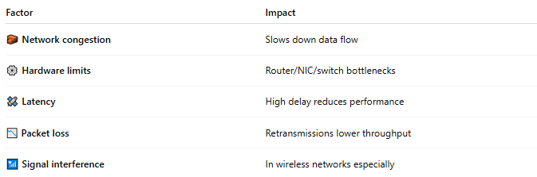
Factor | Impact
🧱 Network congestion | Slows down data flow
⚙️ Hardware limits | Router/NIC/switch bottlenecks
🛰️ Latency | High delay reduces performance
📉 Packet loss | Retransmissions lower throughput
📶 Signal interference | In wireless networks especially

🆚 Throughput vs Bandwidth
# Source: AI Source: Provided by: [Data Path: Persons Table -> ID Column: 1, Name_En Column: Motasem Essam] -> From: [ChatGPT] on [12/18/2025]
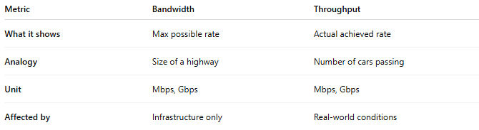
Metric | Bandwidth | Throughput
What it shows | Max possible rate | Actual achieved rate
Analogy | Size of a highway | Number of cars passing
Unit | Mbps, Gbps | Mbps, Gbps
Affected by | Infrastructure only | Real-world conditions

📊 Use in Real Life
# Source: AI Source: Provided by: [Data Path: Persons Table -> ID Column: 1, Name_En Column: Motasem Essam] -> From: [ChatGPT] on [12/18/2025]
- 📥 Download speeds
- 🎥 Streaming performance
- 📞 VoIP call quality
- 🧪 Used in tools like iperf, Speedtest.net, or network monitors

✅ Summary
# Source: AI Source: Provided by: [Data Path: Persons Table -> ID Column: 1, Name_En Column: Motasem Essam] -> From: [ChatGPT] on [12/18/2025]
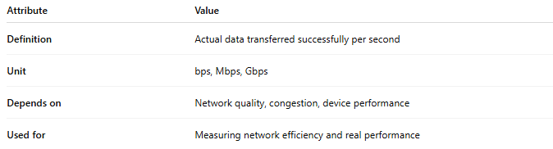
Attribute | Value
Definition | Actual data transferred successfully per second
Unit | bps, Mbps, Gbps
Depends on | Network quality, congestion, device performance
Used for | Measuring network efficiency and real performance

